**Final Report**

**ON**

**“Financial indicators analysis of selected German manufacturing companies”**

**Submitted to:**

**Md. Erfan**

**Assistant Professor**

**Department of Computer science and engineering**

**University of Barishal**

**Submitted by:**

**Md. Mahafuzur Rahman**

ID: 01-044-08

**Date of submission: 08-12-2024**

**Title**

***“Financial performance analysis of selected German manufacturing companies”***

**Table of Contents**

**Introduction:** 1

**Challenges:** 2

**Data Availability and Access**: 2

**Complex Accounting Practices**: 2

**Economic and Industry Factors**: 2

**Financial Statement Limitations**: 2

**Time Constraints**: 3

**Data and Methodology** 4

**Data:** 4

**Methodology:** 4

**Data Analysis and Results** 4

**Question no.1** 4

**Question no.2** 4

**Question no.3** 6

**Question no.4** 7

**Question no.5** 8

**Question no.6** 9

**Question no.7** 10

**Question no.8** 10

**Question no.9** 11

**Question no.10** 12

**Conclusion** 13

# **Introduction:**

The manufacturing sector in Germany is one of the most critical contributors to the country's economy, renowned for its high productivity, technological innovation, and global competitiveness. Understanding the financial performance of German manufacturing companies is essential for investors, policymakers, and business leaders to assess operational efficiency, profitability, and long-term sustainability. This research aims to analyze the financial performance of a selected German manufacturing company, focusing on its financial health, growth patterns, and challenges within the context of the global market.

The study will utilize financial statements, key performance indicators (KPIs), and ratio analysis to evaluate critical aspects such as profitability, liquidity, solvency, and operational efficiency. By comparing financial performance over a specified period, the research will identify trends, strengths, and weaknesses that may inform strategic decisions for the company’s future growth. Additionally, the analysis will provide insights into how external factors, such as global economic conditions, regulatory changes, and market competition, affect the financial performance of the company.

Through this research, the objective is to deliver valuable conclusions that can guide stakeholders in making informed decisions and contribute to broader discussions on the financial strategies of German manufacturing firms in a dynamic and competitive global economy.

# **Challenges:**

## **Data Availability and Access**:

One of the most significant challenges in this research is gaining access to accurate and comprehensive financial data. German manufacturing companies, particularly publicly traded ones, disclose their financial information in annual reports and regulatory filings. However, private companies may not disclose detailed financial statements or other critical performance metrics. Additionally, some firms may have financial data that is too general, making it difficult to conduct a granular analysis. Ensuring that the data is up-to-date, reliable, and consistent is another hurdle

## **Complex Accounting Practices**:

Different manufacturing companies may follow varying accounting principles, even within Germany. While German companies adhere to International Financial Reporting Standards (IFRS) or the German Generally Accepted Accounting Principles (HGB), there may still be differences in how certain financial metrics are calculated or reported. This can create challenges in comparing financial data across different time periods, industries, or companies. Differences in depreciation methods, inventory valuation, or recognition of revenues can complicate the analysis

## **Economic and Industry Factors**:

The performance of a German manufacturing company is influenced by several macroeconomic and industry-specific factors, such as fluctuations in global demand, supply chain disruptions, labour costs, and technological advancements. Isolating the direct impact of these factors on the financial performance of a single company is challenging, especially when external factors like geopolitical tensions, inflation, or trade policies (e.g., Bruit, US-China trade war) also play a role. Separating the effects of these externalities from the company’s own operational performance is a complex task.

## **Financial Statement Limitations**:

While financial statements provide a snapshot of a company's financial health, they do not capture non-financial elements such as customer satisfaction, employee productivity, or brand reputation, which can significantly influence long-term success. Relying solely on quantitative data without considering qualitative factors can provide an incomplete picture of the company's overall performance

## **Time Constraints**:

Given the vast amount of data and complex variables involved in a comprehensive financial analysis, time constraints can be a significant challenge. The research requires deep analysis of historical data, industry trends, and macroeconomic factors. However, limited time for data collection, analysis, and report writing may limit the scope of the project, reducing its ability to fully capture all the influencing factors

# **Data and Methodology**

## **Data:**

Data for this analysis has been collected from Kaggle. This data shows quarterly financial performance like revenue, Net income, Liability, ROA, ROE, and Asset for some German manufacturing firms. It is a panel data contain a period from 2017 to 2024.

## **Methodology:**

To analysis the performance of industry and company a question and answer method applied. 10 question maiden and try to solve the question. For this purpose several software used. Some of them like MS word, MS power point, MS excel, Google docs, Chat gpt, etc.

# **Data Analysis and Results**

**Question no.1: What is the average revenue of Volkswagen for 2023?**

**Answer:**

To find the Average we used average function for targeted company’s column for selected time period

|  |  |
| --- | --- |
| **average revenue of Volkswagen for 2023 =** | 13659128146 |

Formula: =AVERAGE (C26:C29)

**Question no.2: Show the percentage of revenue to net income for 'Deutsche Telekom AG' and ‘SAP SE' for 2017 to 2024.**

**Answer:**

For this question we separate the target company and their selected time period data like revenue and net income. Then used percentage formula to find the answer.



**Question no.3: Graphically show the 'Merck KGaA' ROA trend for 2017 to 2024**

**Answer:**

Used pivot table to separate wanted data for graph. The used graph tool to show ROA trend



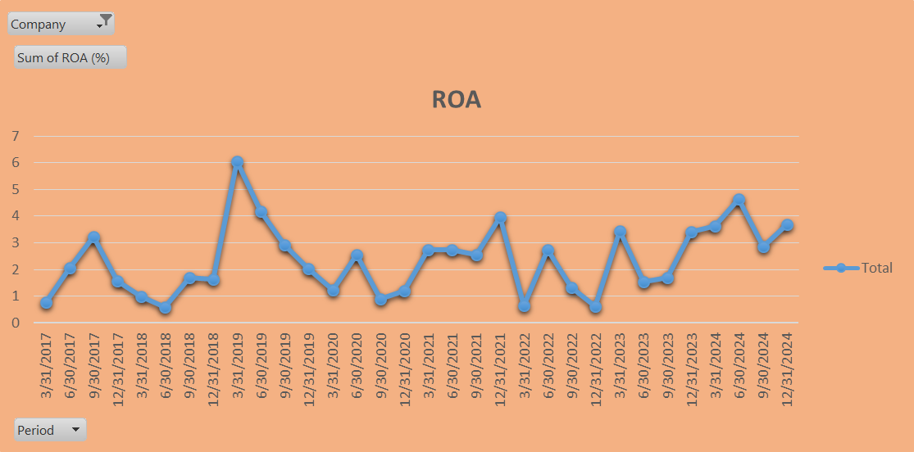

**Question no.4: Which company have the highest asset in last quarter of 2024?**

**Answer:**

Used pivot table



**Question no.5: what is the revenue of all company for 2023 and 2024?**

**Answer:**



**Question no.6: compare net income between BMW and Porsche for 2017 to 2024**

**Answer:**



**Question no.7: what is the average ROE for 2021**

**Answer:**



**Question no.8: show the market cap of all company in 2024**

**Answer:**



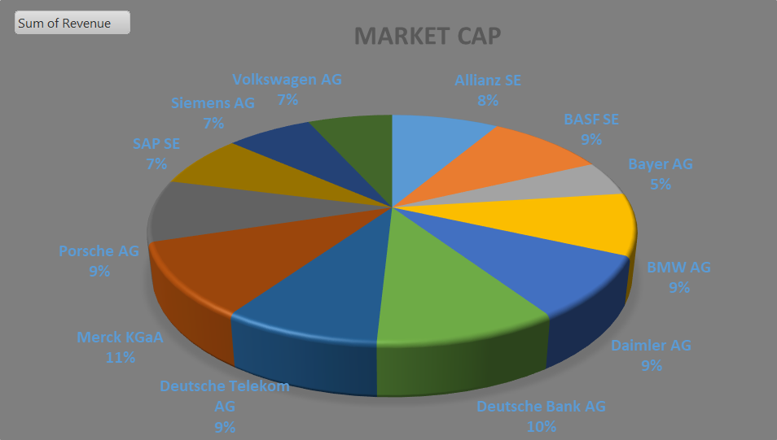

**Question no.9: Find the correlation between 'Debt to equity' and 'net income' for Volkswagen AG, BMW AG, Porsche AG.**

**Answer:**



Formula: =CORREL(B4:B35,C4:C35)

**Question no.10: calculate the Deutsche group total net income for 2024**

**Answer:**



# **Conclusion**

The financial performance evaluation of selected German manufacturing companies reveals critical insights into the operational efficiency, profitability, and overall financial health of the industry. Through the analysis of key financial metrics such as liquidity ratios, profitability ratios, solvency ratios, and efficiency ratios, this study highlights the strengths and weaknesses of the selected companies within the competitive landscape.

The findings indicate that while German manufacturing companies demonstrate robust revenue generation and operational efficiency, certain challenges persist, such as fluctuating profit margins and exposure to external economic factors. The industry’s resilience is supported by its innovative capacity, technological advancement, and strong export orientation, but the study underscores the need for continued focus on cost management and adaptability to global market trends. This evaluation also emphasizes the importance of strategic decision-making in sustaining financial stability. By leveraging their strengths and addressing identified gaps, these companies can enhance their competitive position and ensure long-term growth. Future research may extend this analysis by incorporating environmental, social, and governance (ESG) criteria to assess how sustainability initiatives impact financial performance in the German manufacturing sector